Objective
The objective of this initial database design is to define the basic structure of the Business Intelligence database based on the identified project requirements. This design provides a blueprint for organizing business data into different tables and defining how these tables are connected.
The main purpose of this design is to identify the required tables, attributes, primary keys, foreign keys, and relationships before implementing the actual database. This helps ensure that the database is properly structured for storing, managing, and analyzing business information.
The design focuses on supporting business reporting, data analysis, and decision-making by organizing important business data related to customers, products, sales, employees, regions, and time periods.

Database Design Approach
The database is designed using a Star Schema approach, which is commonly used in Business Intelligence and Data Warehouse systems.
In the Star Schema model, one central Fact Table is connected with multiple Dimension Tables. The Fact Table contains measurable business information, while Dimension Tables contain descriptive information that helps analyze the facts.
In this database design:
- The Sales table is considered the central Fact Table because it contains important business measurements such as quantity sold and sales amount.
- The remaining tables act as Dimension Tables because they provide additional details required for analysis.
The Star Schema design improves data organization, simplifies reporting, and allows efficient analysis of business performance.

Tables Included
The initial database design consists of the following tables:
Table Name | Table Type | Purpose
Customers | Dimension Table | Stores customer details and customer-related information
Products | Dimension Table | Stores product information required for product analysis
Categories | Dimension Table | Stores product category details
Orders | Transaction Table | Stores customer order information
Sales | Fact Table | Stores sales transactions and measurable business values
Regions | Dimension Table | Stores geographical information
Employees | Dimension Table | Stores employee details and performance-related information
Date | Dimension Table | Stores time-related information for analysis

Primary Keys
Primary keys are unique identifiers used to identify each record in a table. Each table contains a primary key that ensures every record can be uniquely identified.
The primary keys used in the database design are:
Table Name | Primary Key | Description
Customers | Customer_ID | Unique identifier for each customer
Products | Product_ID | Unique identifier for each product
Categories | Category_ID | Unique identifier for each product category
Orders | Order_ID | Unique identifier for each order
Sales | Sales_ID | Unique identifier for each sales transaction
Regions | Region_ID | Unique identifier for each region
Employees | Employee_ID | Unique identifier for each employee
Date | Date_ID | Unique identifier for each date record

Foreign Keys
Foreign keys are attributes used to establish relationships between different tables. They reference primary keys from other tables and maintain connections between related data.
The foreign key relationships in this database are:
Table | Foreign Key | References
Customers | Region_ID | Regions(Region_ID)
Products | Category_ID | Categories(Category_ID)
Orders | Customer_ID | Customers(Customer_ID)
Orders | Employee_ID | Employees(Employee_ID)
Sales | Order_ID | Orders(Order_ID)
Sales | Product_ID | Products(Product_ID)
Sales | Customer_ID | Customers(Customer_ID)
Sales | Date_ID | Date(Date_ID)
Employees | Region_ID | Regions(Region_ID)

Table Relationships
The database tables are connected through primary key and foreign key relationships.
The major relationships are:
- Regions and Customers
A region can have multiple customers, but each customer belongs to one region.
Relationship:
Regions 1 -------->Customers
- Regions and Employees
A region can have multiple employees, but each employee belongs to one region.
Relationship:
Regions 1 -------->Employees
- Customers and Orders
A customer can place multiple orders, but each order belongs to one customer.
Relationship:
Customers 1 --------> Orders
- Employees and Orders
An employee can manage multiple orders, but each order is handled by one employee.
Relationship:
Employees 1 -------- >Orders
- Orders and Sales
An order can contain multiple sales records.
Relationship:
Orders 1 -------- >Sales
- Products and Sales
A product can appear in multiple sales transactions.
Relationship:
Products 1 -------- >Sales
- Categories and Products
A category can contain multiple products.
Relationship:
Categories 1 -------->Products
- Date and Sales
A date can have multiple sales transactions.
Relationship:
Date 1 -------- >Sales

ER Diagram
The Entity Relationship Diagram represents the visual structure of the database design. It shows all tables, attributes, primary keys, foreign keys, and relationships between different tables.
The ER Diagram is created using Draw.io and represents the Star Schema design where the Sales table acts as the central Fact Table connected with multiple Dimension Tables.
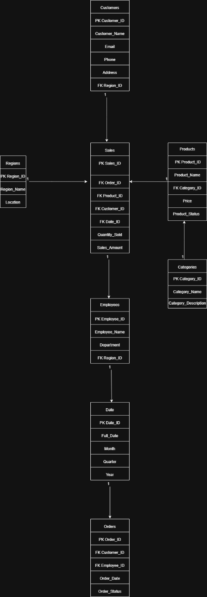
Conclusion
The initial database design provides the foundation for implementing the Business Intelligence database. It defines the required tables, keys, and relationships needed to organize business data effectively.
By following the Star Schema approach, the database structure supports efficient reporting, data analysis, and generation of business insights. This design can be further used as a reference for creating the actual database implementation.

